**ASSIGNMENT: INTRODUCTION TO COMPUTING**

***THE PROBLEMS WHICH I HAVE FACED WHILE DOING THE LEVELS OF PYTHON CODING FROM CODE SCHOOL AND THE EXPLINATION HOW I FIXED THEM:***

1-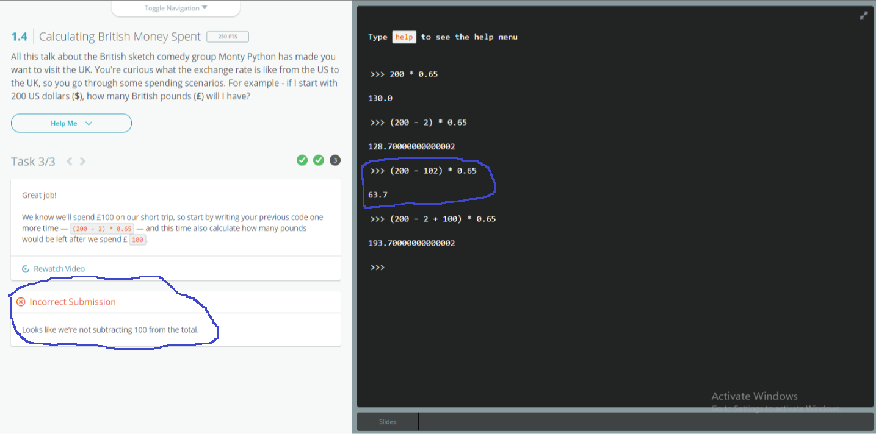

The first mistake I was doing while writing this code was, I was adding 100 and 2 and then subtracting them from 200. Then I fixed the problem by first subtracting 2 from 200 and then by adding with 100. I faced this bug because I didn’t care about operator precedence. When I read operator precedence again, then I became able to fix the error.

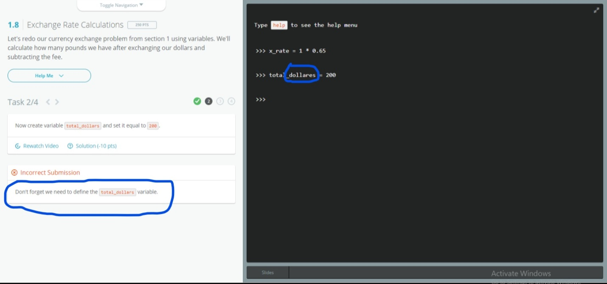

2- Second problem I faced during defining the variables. Actually I was writing the name of variable wrong. According to the demand the name of variable was (total_dollars), while I was writing (total_dollares). That’s why I faced the problem, later on when I saw that I’m writing the name of variable wrong, so correct the name of variable and the problem solved.

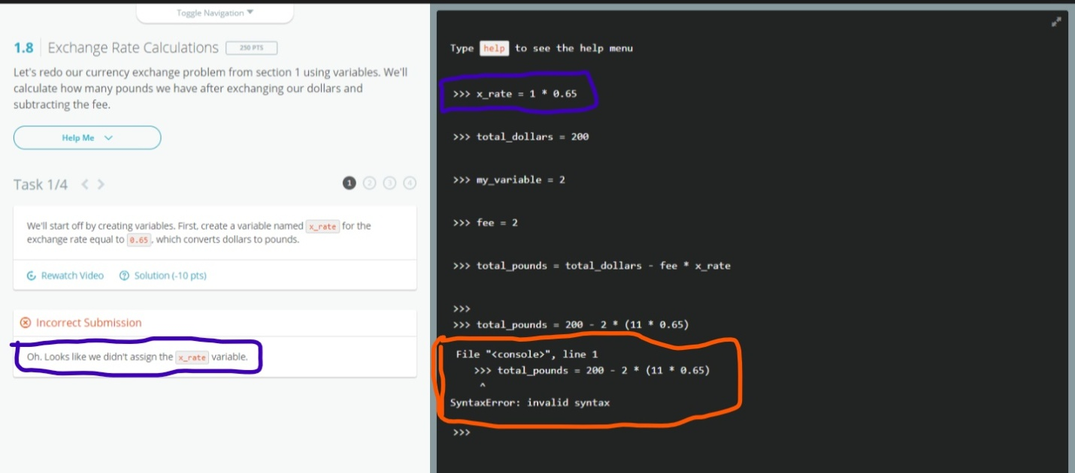

3- Here I was committing two mistakes one is marked with blue and second one is marked with orange color. The mistake inside blue color is saying that I’m not assigning the x-rate variable, it means I’m not giving any value to x-rate variable, so solved this problem by assigning the value to x-rate which is equal to 0.65. Second mistake is a syntax error. In picture you can see a clear indentation, which actually doesn’t need any indentation there. I remove that indentation and in next step problem solved.

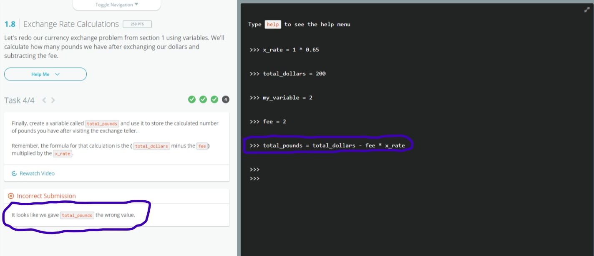

4- again here I was committing the mistake of precedence, in the question they clearly asked to minus total dollars from fee first and then multiply the answer with x_rate, but according to my code and operator precedence first fee is multiplied with x_rate and then the answer is subtracted from total dollars, which was wrong. To solve this problem I put brackets around total_dollars and fee, due to which the precedence of minus sign will increase, because it is found in bracket and we know that the precedence of bracket is more than multiplication. In this way first total_dollars will be subtracted from fee and the multiplied with x_rate. And the correct code for this will be:

**Total_pounds = (total_dollars – fee) * x_rate**

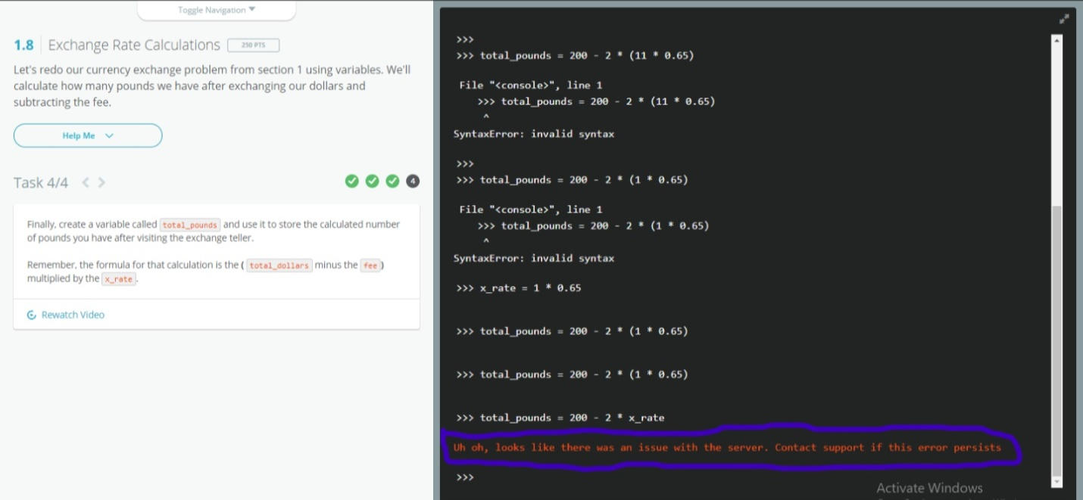

5-while writing the codes I encounter this problem also, in this problem you don’t have to be too much worried about this because this time there is no wrong with your code, this time your internet may not work or server may not be responding.

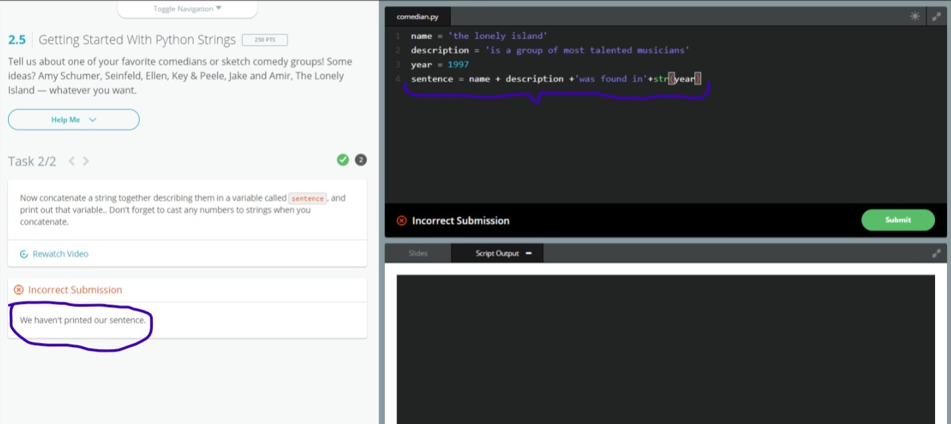

6- I was committing so simple mistake here, and that is I was giving the command to print the senence. When I gave command **print(sentence),** the error removed.

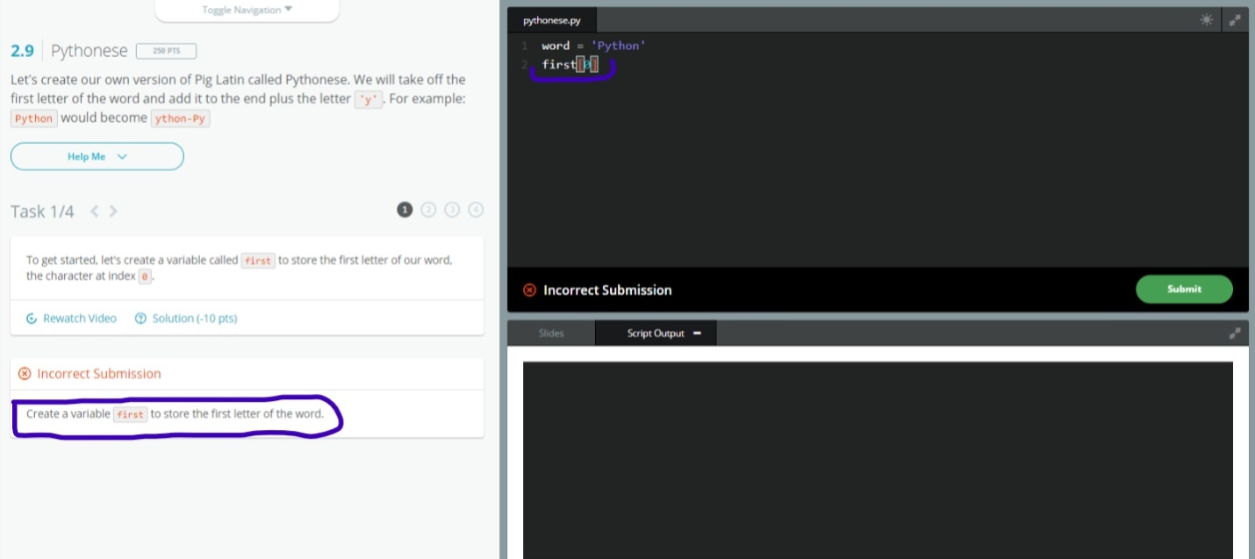

7-here the question is to store the first letter of the word, what mistake I was doing is first=[0], this was wrong. Then I fixed the problem by re writing the code like first[0]. I removed the equal sign and the error fixed.

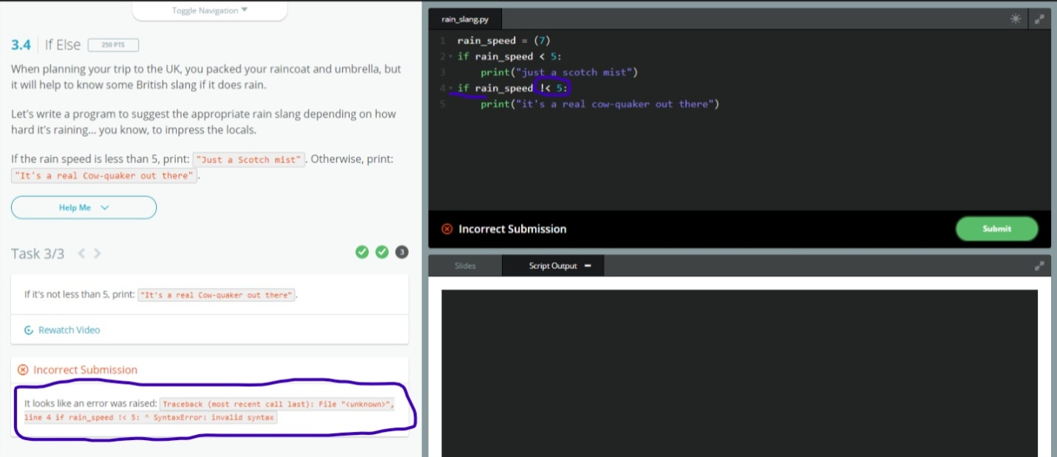

8-i was committing two mistakes over here, first one is I was using the sign **!<** for not less then to, but it is a syntax error, after reading more about signs I came to know that there no such a sign for not less then. And the second mistake is I was using **if** again and again in the same body of function, then I remove **if** and add **else** instead of **if** then the error fixed.



These were some mistakes and their fixatation above. After all I have completed all the three levels of try python.

**THE END**